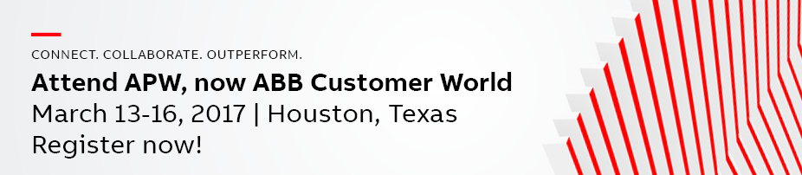

*copy and paste the text below into an email*

Dear <Customer name>,

Since 2009, APW has brought together professionals from the utility, industry, transportation and infrastructure sectors for our premier educational and collaboration event in North America. APW has developed to be even more focused about your needs and, under the new name of ABB Customer World, will take on some of the most pressing issues you face today, with a view toward how you can leverage technology to make the best choices.

I want to extend an invitation for you to join us in Houston, March 13-16, 2017, and experience for yourself all that APW, now ABB Customer World, has to offer. Together with many customer attendees, we will have ABB technical experts, industry leaders, ABB management and business partners focused on how we succeed together in facing the opportunities and challenges ahead.

Working closely with our advisory boards, we’ve built on our past success and taken the event and our solutions to the next level. This biennial event offers the opportunity to experience all of ABB’s technology, products and expertise under one roof, and it’s also a great chance to meet and learn from peers working in your industry and professional specialty.

Some highlights for this year include:

- A new “Women in industry” professional development track on Wednesday, March 15, sponsored by EUCI. This program begins with a special keynote speaker, Paula Gold Williams, President and CEO of CPS Energy. In the afternoon, a three-hour workshop to help attendees better navigate the internal politics of the workplace will be instructed by a team from the highly effective Global Strategies Group of New York City.

- A track within our Business forum dedicated to “Effective project management,” sponsored by TwentyEighty.

- The Peer-to-Peer Discussions track offers a place for open dialog among attendees to share experiences, ask questions and talk about concerns or trends around a specific topic.

We’ve made some exciting modifications for this year’s event. What hasn’t changed is our commitment to make this the most valuable use of your time. Our goal is to give you an innovative look at new ideas, trends and technologies that will impact the way your company moves forward in an era of digital transformation. Plus, event registration is FREE for our customers and industry professionals.

Visit the event website at www.abb.com/acw for additional information about the event, registration, workshop schedule, hotels and more. If I can answer any questions about APW, now ABB Customer World, for you, please let me know.

Best regards,

<Account manager name>
<Title>

