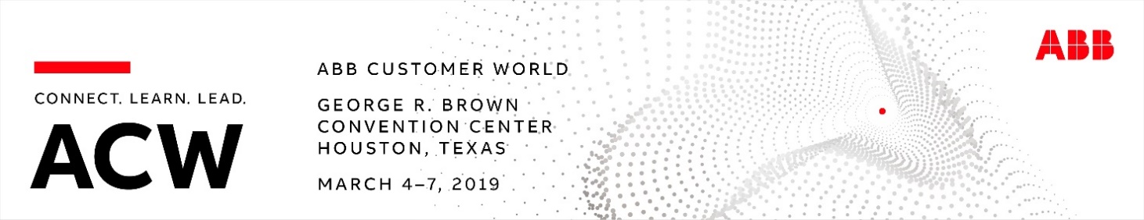

Dear <Customer name>,

Since 2009, ABB has brought together professionals across multiple sectors for our premier educational and collaboration event in North America. I want to invite you to join us in Houston, March 4-7, 2019, and experience for yourself all that ABB Customer World (ACW) has to offer.

We developed ACW to address the most pressing issues you face, from increasing productivity to meeting rising customer expectations. The event provides an unparalleled opportunity to engage with your industry peers and our experts to discuss the future of manufacturing, mobility, work, energy and cities – and how it impacts your business.

Working closely with our advisory boards, we’ve built on our past success and taken the event and our solutions to the next level. Choose from hundreds of workshops, hands-on training sessions, keynotes and panel discussions, and talk directly to the people behind ABB’s technology and solutions. At the request of past attendees, we’ve increased our hands-on training sessions by 50% compared to the 2017 event.

This year, you’ll notice that some of our well-known brands like Baldor and Thomas & Betts have been absorbed into the overall ABB brand. We will also welcome our newest members of the ABB Group, B&R Industrial Automation and GE Industrial Solutions, to the event for the first time.

Our event team remains committed to making ACW the most valuable use of your time. Event registration is FREE for all ABB customers and industry professionals.

Visit the event website at events.abb/acw for additional information on registration, workshop schedules, hotels and more. If I can answer any questions about ABB Customer World for you, please let me know.
I hope you will join us to connect, learn and lead.
Best regards,

<Account manager name>
<Title>

