—
ABB Customer World Distributor Social Media Promotion

As a distributor at ABB Customer World, you have the opportunity to meet with sales contacts, make new connections, and learn about potential products to add to your portfolio. We’ve provided ideas, messages and images for you to use to promote your experience at ABB Customer World, encourage your customers to join you, and help you make those new connections. Please ensure that you use this link to registration for any posts you make: https://ad.doubleclick.net/ddm/clk/435135430;237698738;q

A few quick reminders:
- Always use the event hashtag in your posts, even on LinkedIn (hashtags now work as a search function there too). Our event hashtag is #ABBCW. You may also include brand hashtags such as #ABB_Ability, #YuMi, or #Carlon or #DodgePT.
- All posts perform better with images or videos. Please include one of the photo or video options at the bottom of this document.
BEFORE THE EVENT
Share the event: using your own social media accounts, help raise visibility for ABB Customer World. Always try to promote the event first, your involvement secondarily.
LinkedIn or Facebook:
ABB Customer World will be back in Houston this coming March, with 120,000 sq. ft of exhibits and over 500 workshops, hand-on training, and panels. Join me and *Company Name* at #ABBCW where we can Connect. Learn. Lead. Together.
Did you make it to ABB Customer World in 2017? You won’t want to miss the 2019 event, coming in March. Join *Company Name* at this year’s event where we can connect, learn, and lead into the future of the electrification industry. Register for free and let me know if I’ll see you there!
Twitter:
ABB Customer world is four days full of amazing content on *replace with topic*. Register for free and join me in #Houston this March. #ABBCW
With 120,000 sq ft of exhibits, over 500 courses, in four days, #ABBCW is the conference you won’t want to miss in 2019. What makes it even more special? Mike Rowe, TV host known for Dirty Jobs will be a keynote speaker! Register for free here:

Send personal invitations: use Facebook messages, Twitter direct messages, and LinkedIn messages to invite key, influential attendees, and other event attendees to join your presentation.
Make sure to tell them the why, where and when you’ll be presenting, and invite them to connect with you afterwards.
When you get positive responses, save their names in a list for the day of the event.
Message Script:
Hello *Contact Name*,
Since 2009, ABB has brought together professionals across multiple sectors for our premier educational and collaboration event in North America. I want to invite you to join me in Houston, March 4-7, 2019, and experience for yourself all that ABB Customer World (ACW) has to offer.
ABB developed ACW to address the most pressing issues you face, from increasing productivity to meeting rising customer expectations. The event provides an unparalleled opportunity to engage with your industry peers and our experts to discuss the future of manufacturing, mobility, work, energy and cities – and how it impacts your business.
Event registration is FREE for all ABB customers and industry professionals.
Visit the event website at events.abb/acw for additional information on registration, workshop schedules, hotels and more. If I can answer any questions about ABB Customer World for you, please let me know.
I hope you will join *Distributor Name* to connect, learn and lead.
Best regards,
*Your Name and Title*

Deck out your profile: Upload the banner image at the bottom of this document to your LinkedIn profile. Remember to update your LinkedIn headline to invite people to meet with you at ABB Customer World 2019. Say something like: “Join me for free at ABB Customer World 2019 with the link in my profile.” Then, make sure you update your profile custom links with the URL at the top of this document.
DURING THE EVENT
Arriving in the city: When you get to the city or the venue, post about it using the event hashtag on your social networks and in the ABB Events app so that it appears in the app feed and on the Social Wall screens around the convention center.

Ideas on what to post:
What your (positive) thoughts are on the city or venue
What you are excited about doing
Who you are looking forward to seeing
Photos of the city, venue, people you meet.

Post photos: Whether you are sharing this on Instagram, Twitter, Facebook or even LinkedIn- show that you are active at the event. Take selfies with people, a nice view, or the equipment you’re most excited to find. Don’t forget about the ABB Events app where you can share photos directly with attendees, and auto-post to your social networks once you’ve connected them!

Send reminders: Remember that list you made with the positive responses from influencers? Pull that list backup and send them a quick hello and request to meet up, and how you are looking forward to keeping up with them afterward. If they have already joined the app, you can send them a message directly via ABB Events, or use the same method in which you first connected.

AFTER THE EVENT

Interact, interact, interact: Talk with people. Like their status, and make sure to share how they can keep in contact with you. Share pictures of your favorite moments from the event with the #ABBCW tag.

Use LinkedIn: When possible, connect with people that you met at the event on LinkedIn.

Keep participating in the conference: Stay in the conversation by attending sessions and connecting with the influencers, speakers, and customers on your list. Building face to face connections will help you when it comes to connecting online.

MEDIA

IMAGES
LinkedIn Profile Banner: http://search.abb.com/library/Download.aspx?DocumentID=9AKK107046A9883&LanguageCode=en&DocumentPartId=&Action=Launch
Example:
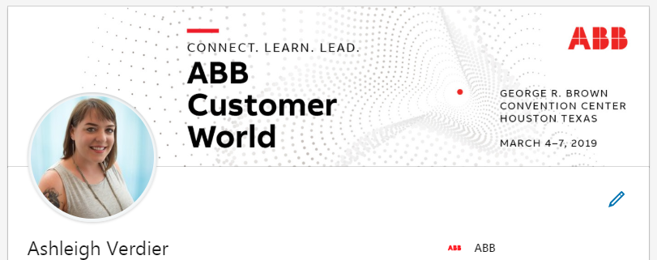

Social Post Image: http://search.abb.com/library/Download.aspx?DocumentID=9AKK107046A9887&LanguageCode=en&DocumentPartId=&Action=Launch

VIDEOS
ABB Customer World People Parade: https://youtu.be/2WkIYrwpYkg
ABB Customer World 2017 Wrap-up: https://youtu.be/gwKGEqNtYBw
Connect Video: https://youtu.be/G4OLFXHJsD4
Learn Video: https://youtu.be/oQMGgEdJ9aA
Lead Video: https://youtu.be/p6daZ85813g

