Copy and paste this text into an email to invite your customers to attend the Power digital conference!
Subject: Register for ABB Automation & Power World’s digital conference for the power industry!

Dear <<Name>>,
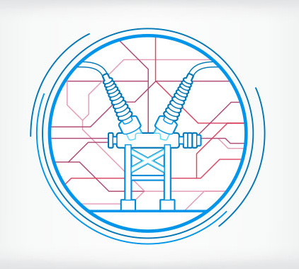
Industry changes are more rapid and dramatic than ever. From new and evolving technologies to the internet of things, the need to adapt and plan for the future is becoming more integral for our daily and long term performance.

Although we understand taking the time out of an already full schedule is a task in and of itself, not taking time out to learn how to deal with today’s challenges and more of what’s to come seems a riskier proposition.

As part of our Automation & Power World conference program, we are pleased to offer you the chance to attend, free of charge, a digital conference on Risk, reliability & recovery.

Why should you participate?
With an aging infrastructure, technical experts approaching retirement age, new regulations and the need to manage budget constraints for both capex and O&M spending, this online event offers a unique setting for exposure, education and interaction. With two main tracks during the conference, one on “Preparing for the future grid” and the second on “Optimizing reliability today,” we will address these challenges head on.

Your participation is equally important to enrich the conference. You are encouraged to actively engage in the conversation during presentations and panel discussions!

Still not convinced? Here are some additional reasons to register and attend:
- Easy one time registration to attend all sessions
- Customize your agenda and attend the sessions that matter to you most
- Make it a group event and participate in webinars with members of your team
- Earn Professional Development Hours (PDHs) for each webinar you attend
- Find practical information you can use today AND tomorrow
And it’s free. Register and attend from anywhere with an internet connection. There are no conference fees and no travel expenses.
Don’t miss this free live stream event, register here today!
In conjunction with ABB Automation & Power World, this series offers the benefits of an in-person event combined with an online experience. We hope you enjoy this exclusive event. And don’t forget, ABB Automation & Power World 2017 will take place March 13-16, in Houston, Texas. It is also free to attend in person! Find out more here: http://new.abb.com/apw.
Sincerely,
<< Your name here >>

