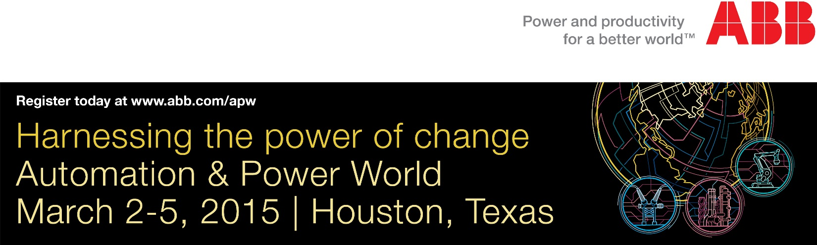
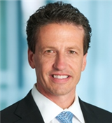  Greg Scheu | Since 2009, ABB Automation & Power World has brought together professionals from utilities, industries and infrastructure for our premier educational and collaboration event  in North America.  I want to extend an invitation for you to join us in Houston, March 2-5, 2015, and experience for yourself all that ABB Automation & Power World has to offer. Together  with many customer attendees, we will have ABB technical experts, industry leaders,  ABB management and business partners focused on how we succeed together in  facing the opportunities and challenges ahead.
Working closely with our Customer Advisory Board, we’ve built on our past success and taken the event and our solutions to the next level. Part of this evolution was the debut of our first-of-its-kind SmartStream digital conference series. We tapped into the same spirit of innovation as we designed our Houston program.
We’ve made some exciting modifications for this event. What hasn’t changed is our commitment to making ABB Automation & Power World the most valuable use of your time. Our goal is to give you an innovative look at new ideas, trends and technologies that will impact the way your company moves forward in a rapidly changing business landscape.
Event registration is FREE for our customers and industry professionals. Just visit www.abb.com/apw
to register or for more information about the event.
We are excited to see you at ABB Automation & Power World 2015: Harnessing the power
of change.
I look forward to seeing you there.

Regards,

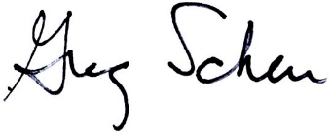
Greg Scheu
Member of the Group Executive Committee
President Americas Region
Managing Director United States

